A guide for the people who use it

Using EmailInsightAI
Your team's mail, read and sorted for you, so nothing important sits waiting.
No technical knowledge needed. This guide explains what the system does, what you see on screen, and how to set it up for your company.

Contents
1 Why this exists
2 How your mail gets here
3 The four questions
4 Your signal bar
5 The life of one message
6 Who sees whose mail
7 Reading and answering
8 A day with the system
9 Your daily report
10 Setting up your company
11 Making it fit your work
12 What it does not do
13 Your first week
14 Questions people ask

1 Why this exists
A busy team receives more mail than anyone can watch. Most of it needs nothing. A little of it needs an answer today. The problem is telling the two apart — and knowing, as a manager, when something has been sitting unanswered for a week.
EmailInsightAI reads your team's incoming mail and works out what each message means. It doesn't replace anyone's inbox. It sits alongside it and answers the questions a manager actually has:
• Who is waiting for a reply from us, and for how long?
• Is anyone writing to us unhappy?
• Which messages are new business, and which are service contracts?
• How much of today's mail is just marketing?
You stop reading mail to find problems. The problems come to you.
Everything you see is a count you can click. If the screen says eleven people are waiting for a reply, clicking that number shows you the eleven messages, oldest first.

2 How your mail gets here
Your company connects its mail once, at the start. After that everything happens on its own.
The system works with company mail on Google Workspace or Microsoft 365. Your IT contact grants it permission to read the mailboxes you name — the same kind of permission an email backup or archiving service uses.
There is nothing for your team to install, no forwarding rule to set up, and no password for anyone to hand over. From your team's point of view, nothing about their mail changes at all.
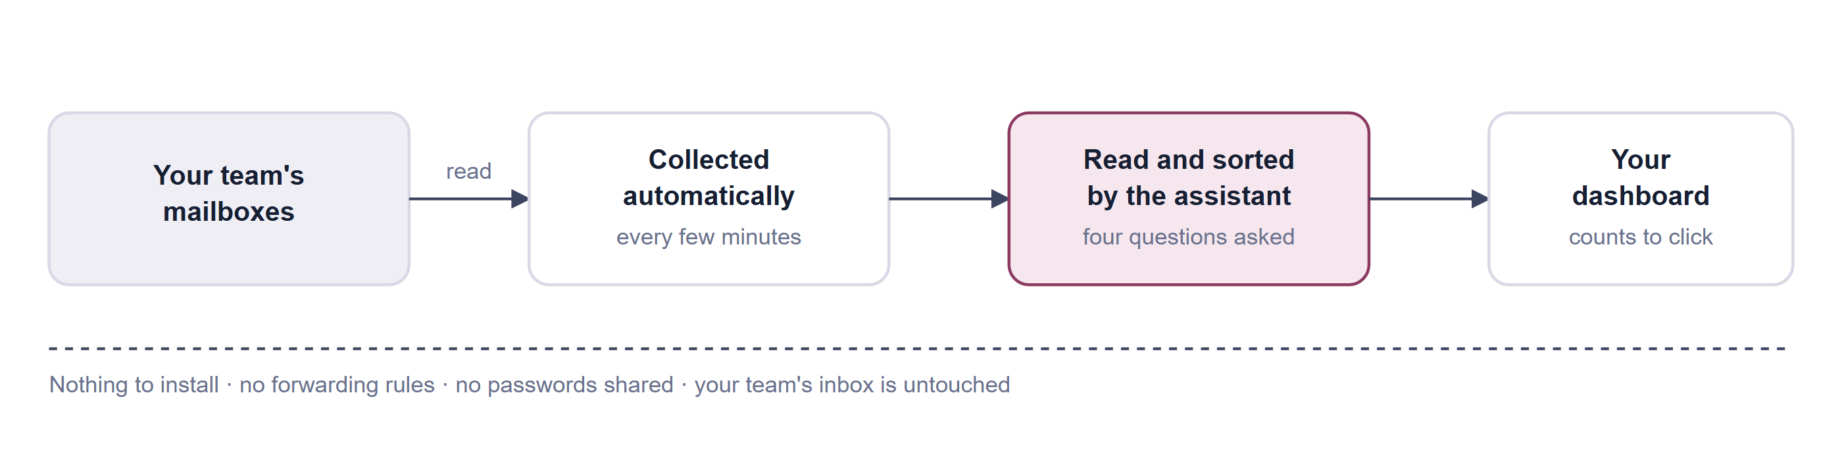
How mail reaches you. Collection runs continuously in the background. New mail is usually on your dashboard within a few minutes of arriving.
One thing to expect at the start
The system begins from the day a mailbox is connected. It does not go back and read years of old mail. Your first day will look quiet; by the end of the first week the counts are meaningful.

3 The four questions
Every message that arrives is read once and judged on four things. These four answers are what every screen, count and report is built from.
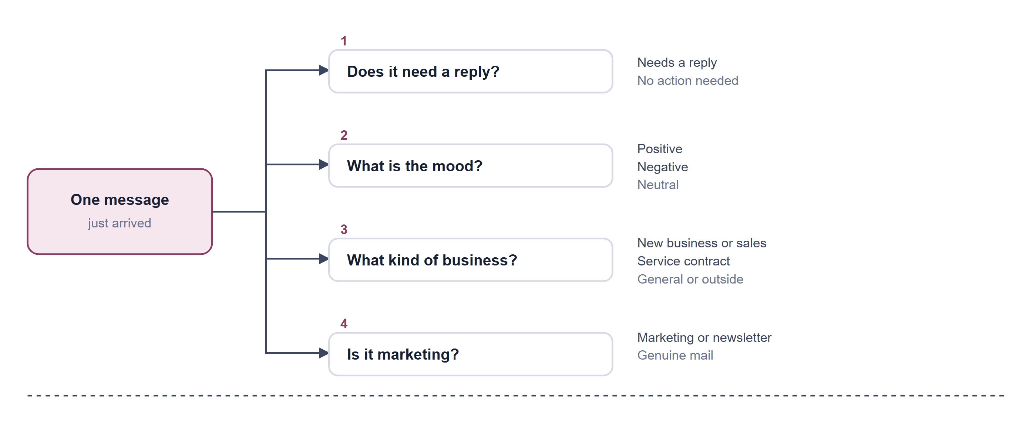
The four questions. Asked once per message, when it first arrives. The answers are kept, so you can always see why a message was sorted the way it was.

What the answers are used for
• Needs a reply drives the most useful number on the screen — the pile of people still waiting to hear from you.
• Mood gives you an early warning. A rise in negative mail for one person is worth a conversation.
• Kind of business separates new enquiries from routine service work, so sales and support can each look at their own pile.
• Marketing is filtered out of every other count, so newsletters never inflate your numbers.
The assistant is very good, not perfect
Judging tone and intent from text is a matter of interpretation, and occasionally a message is filed somewhere you would not have put it. Treat the counts as a reliable guide to where to look, not as a legal record. Every message keeps its original text, so you can always read it yourself and judge.

4 Your signal bar
Across the top of the mail screen sits a row of labels, each with a number. This is the whole product in one line. Click any number to see the messages behind it.
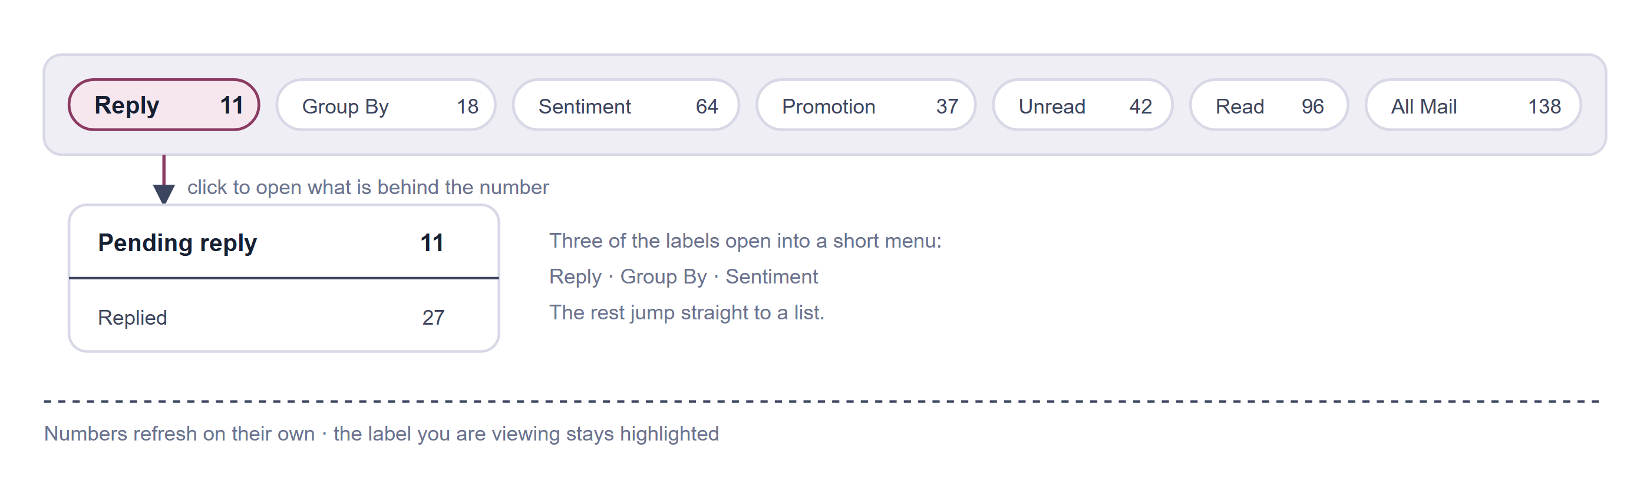
The signal bar. Counts shown here are examples. Reply is the one to watch daily; the others are for looking into a pattern.

What each label means
● Reply | Two piles. Pending reply is everyone still waiting to hear from you — the number to act on. Replied is the conversations that have moved on.
● Group By | Mail split by kind of business: new business and sales, service contracts, plus any groups of senders you have set up yourself.
● Sentiment | Mail split by mood — positive, negative, neutral. Use it to spot a customer getting frustrated before it becomes a complaint.
● Promotion | Newsletters, offers and campaigns, kept out of the way. Worth a glance, never urgent.
● Unread & Read | Whether you have opened the message here, in this system. It has nothing to do with whether the mailbox owner has read it in their own inbox.
● All Mail | Everything collected for the mailbox you are looking at.
● Summary | Asks the assistant to write you a short briefing on the most recent conversations. See chapter 7.

Whose mail am I looking at?
The screen always shows one person's mail at a time — yours by default. When you arrive from your team list, you are looking at that person's mail instead, and their name is shown. If a screen looks unexpectedly empty, check whose mail you are in.

5 The life of one message
This is the part worth understanding properly, because it explains the number you will look at most: how something enters the pending pile, and how it leaves.
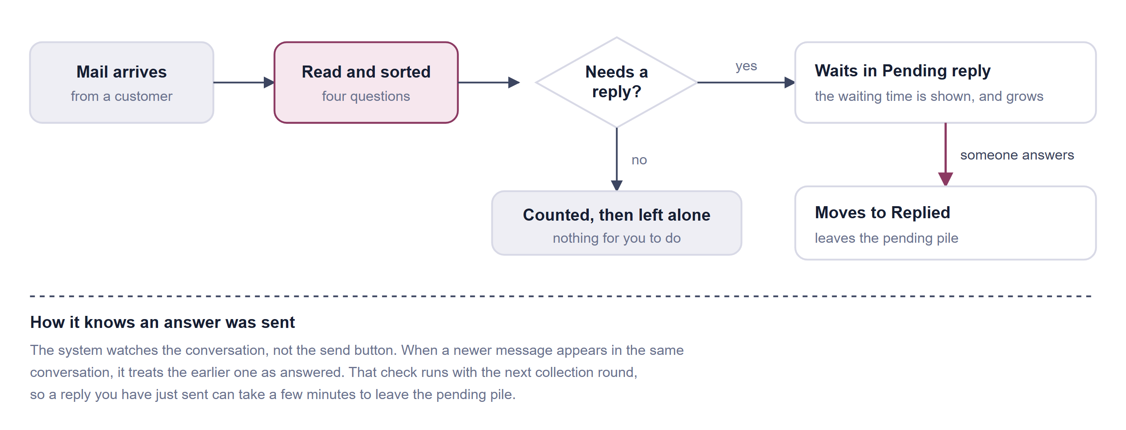
The life of one message. The pending pile is the heart of the product: it only ever contains messages that need an answer and have not had one.
What this gets right  • You never have to mark anything as done — the pile clears itself.  • It works no matter where the reply was sent from: this system, a phone, a laptop.  • The waiting time is real and visible, so the oldest problem is always top. | What to keep in mind  • A reply takes a few minutes to register.  • Any newer message in the conversation counts as movement — including a follow-up from the customer themselves.  • It measures that the conversation moved on, which is very close to, but not exactly, "we answered".

6 Who sees whose mail
There are three kinds of people in the system, and only two of them ever sign in.
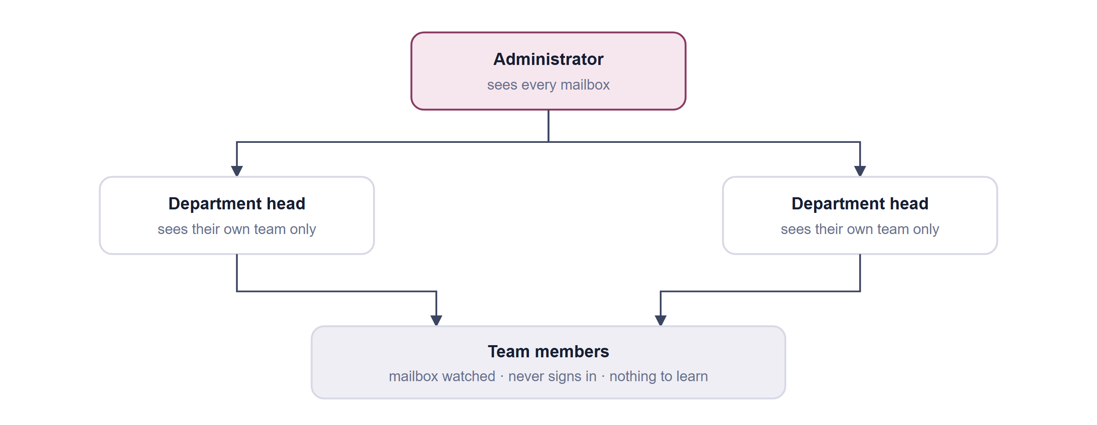
Who sees what. A department head's view is a narrower version of the administrator's — the same screens, fewer people in them.

Administrator
Usually a manager or business owner. Sets the company up, adds people, creates departments, and can see the mail of everyone they added. This is the account that receives the fullest daily report.

Department head
Sees exactly the same screens, but only for the people assigned to them. When someone is made a head they receive an email inviting them to set their own password. A department has one head at a time.

Team member
Their mail is collected and sorted, but they have no login and see nothing. Nothing on their computer changes. If a team member should be able to see the dashboard, make them a department head.
Signing in takes two steps
Your password, and then a six-digit code sent to your email address. The code is valid for five minutes, and you can ask for a new one if it does not arrive. This means someone who learns your password still cannot read your team's mail.

7 Reading and answering

Opening a message
Any row in any list opens into the full message, laid out as it was sent, with a note of whether it had attachments. Opening it here marks it as read for you — it does not touch the mailbox owner's own unread count.

Answering without leaving
Every message has a Reply button. Write your answer and send it, and it goes out from the mailbox owner's own address, inside the original conversation — so the customer sees a normal reply in the normal thread. Nothing marks it as coming from this system.
A moment later, when the next collection round notices the conversation has moved, the message leaves the pending pile on its own.

The instant briefing
The Summary button asks the assistant to read the most recent conversations for that mailbox and write you a short briefing: who wrote, what about, what was asked for, what was decided, and anything with a date attached. It takes a few seconds and is grouped by conversation, newest first.
It is most useful in two moments: coming back from leave, and picking up someone else's mailbox while they are away.
If the briefing comes back empty
Either nothing has been collected for that mailbox yet, or everything collected is marketing — which is deliberately left out of briefings. Marketing mail is never summarised.

8 A day with the system
You are not expected to sit in front of this all day. It is built around one report in the afternoon and a quick look whenever you have a moment.
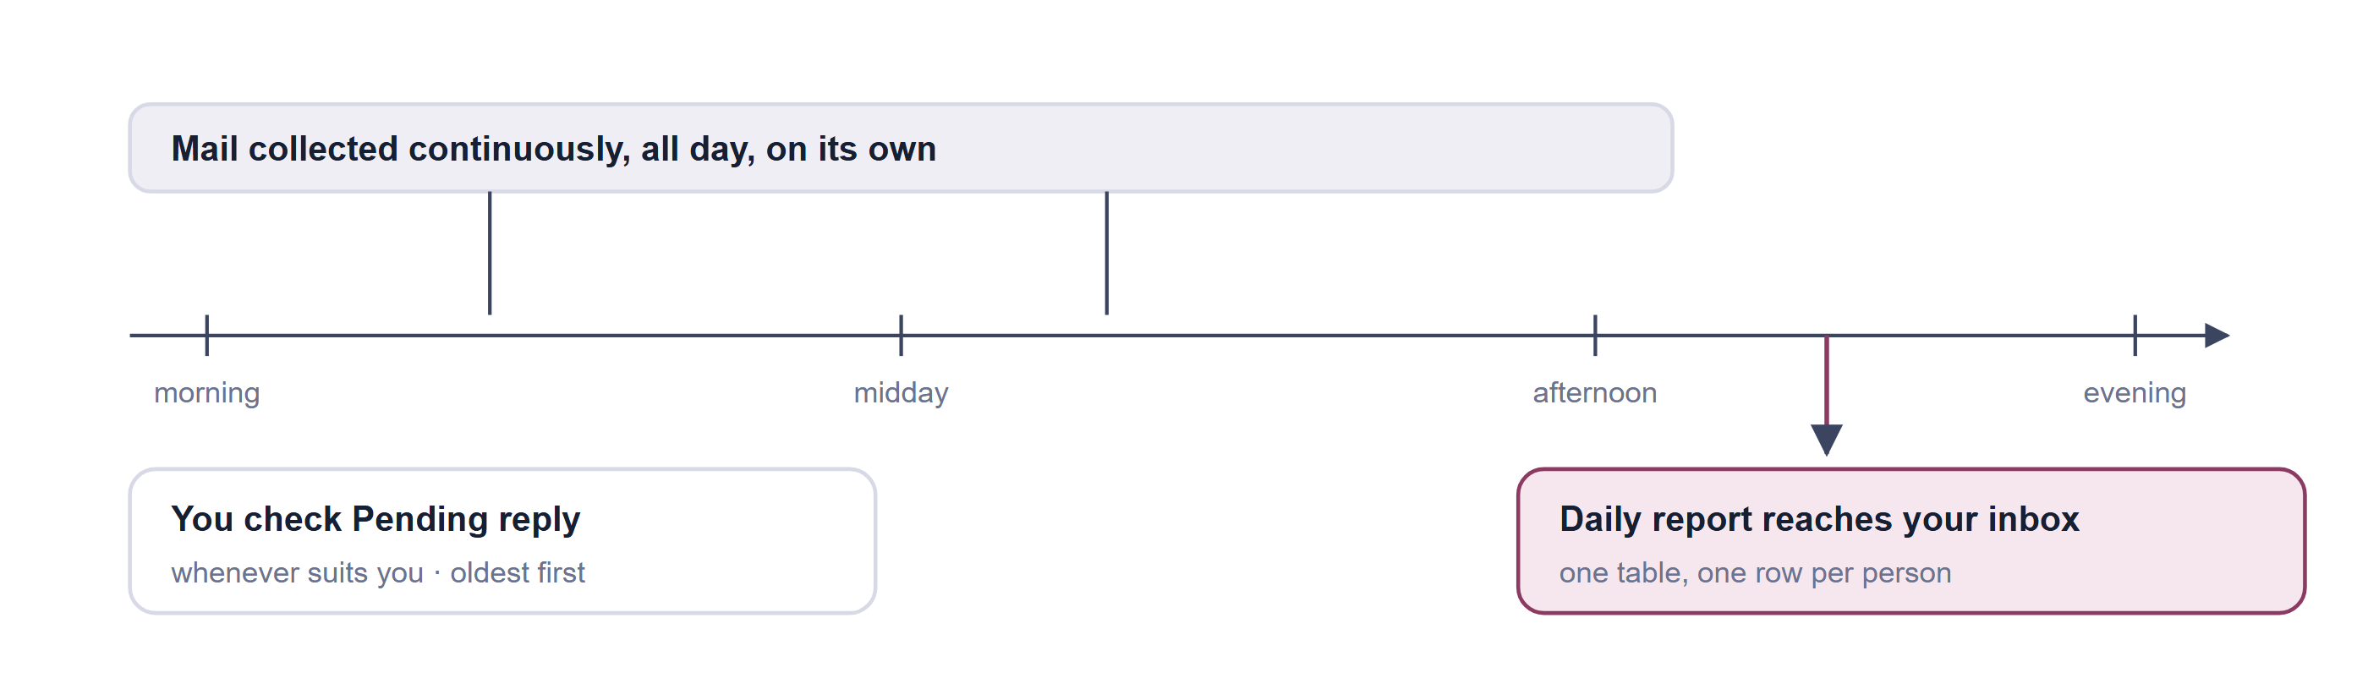
The daily rhythm. Collection needs no attention at all. The only fixed moment in the day is the report.

9 Your daily report
Once a day, every administrator and department head receives one email: a table with a row for each person they are responsible for, and a column for each thing worth knowing.
Each row shows, for that person:
● Positive | Unopened mail with a warm tone.
● Negative | Unopened mail with complaints or frustration. The first column most managers read.
● Neutral | Unopened factual mail — updates, confirmations, routine traffic.
● Waiting over a month | Needs an answer, still has none, and arrived within the last month. This is where things quietly go wrong.
● Waiting over 48 hours | Needs an answer, still has none, arrived in the last two days. Today's work.
● Replied | Needed an answer and got one. Useful as a sense of throughput.
● Sales & Service contracts | Unopened mail of each kind, so you can see where the week's demand is coming from.

Every number in the table is a link. Clicking one opens the dashboard on exactly that person and that pile, so the report is a way into the work rather than just a status update.
You get one report per day
The system prepares reports through a window in the afternoon, but each person receives only one. If yours has not arrived by the evening, tell whoever set the system up — mail delivery is the usual cause.

10 Setting up your company
Setup is done by an administrator and takes about an hour for a typical team, most of it spent filling in one spreadsheet.
1. Add the people whose mail you want watched
Open Add Email and download the sample spreadsheet. It wants three things per person: first name, last name, email address. Fill it in, upload it, and the system checks every address before accepting it.
2. Read the result before moving on
Every row comes back sorted into four groups, and each group can be downloaded as its own spreadsheet so you can fix and re-upload just the problem rows.
3. Create your departments
Under Settings, add a department for each real team — Sales, Support, Accounts. Each needs a name and a short label.
4. Give each department a head
Choose the department, pick one person to lead it, and tick the people who report to them. The new head is emailed an invitation to set their own password. One head per department.
5. Wait a day, then look
Collection starts immediately, but the counts only start meaning something once a day or two of mail has come in. Your first report arrives that same afternoon.

The four groups after an upload
● Valid | Accepted and already being collected. Nothing to do.
● Blank | The row had no email address. Fill it in and upload those rows again.
● Error | The address could not be reached — usually a typo, or an address outside your company's mail system. Check the spelling first, then ask your IT contact whether that mailbox is covered by the permission granted at setup.
● Duplicate | Already in the system. Nothing to do — it is being collected already.

Only company mailboxes can be added
The permission your IT contact granted covers your own company's mail. A personal address, or a mailbox at another company, will always come back as an error. This is a deliberate boundary, not a fault.

11 Making it fit your work
Four settings let you shape what the dashboard emphasises. None of them are required, and all can be changed later.

Important senders
Every sender who writes to you is remembered automatically. Under Email Settings you can mark which of them matter, and see how many messages each has sent and in what tone — a quick way to audit one customer relationship.
One thing to know: your selection is the complete list. Anyone you leave unticked becomes "not important" when you save, so tick everyone who matters, not just the new ones.

Groups of senders
Put related senders into a named group — a key account, a supplier, a project — and that group appears as its own entry under Group By, listing everything from all of its senders together. Deleting a group leaves the senders alone.

Your own domain
Tell the system which email domain is yours, and your sender list splits in two: colleagues writing internally, and everyone from outside. This shows at a glance how much of your team's mail is internal traffic.

Your own keyword
You can give the positive-mail count your own label, so a column reads in your company's language rather than a generic one. It appears on the dashboard and in the daily report.

12 What it does not do
Worth being clear about, so nobody waits for something that is never coming.
• It does not replace anyone's inbox. Your team keeps working exactly as they do now.
• It never answers on its own. Every reply is written and sent by a person. Nothing goes out automatically.
• It does not read old mail. Collection starts the day a mailbox is connected.
• It ignores junk. Anything your mail provider has already judged to be spam is left out of every count.
• It does not move or delete anything in your team's mailboxes.
• It does not watch personal mail. Only the company mailboxes an administrator has added.
• It is not a to-do list. There is nothing to tick off; the pending pile clears itself when a conversation moves on.

13 Your first week
A short path from empty to useful.

Day one
☐ Sign in and get through the two-step code once, so you know it works.
☐ Upload your team spreadsheet and clear any Error rows.
☐ Create your departments and appoint their heads.
☐ Check that each head received their invitation and can sign in.

Day two
☐ Open Pending reply and see whether the oldest items look right.
☐ Read one message end to end and check it was sorted sensibly.
☐ Confirm your first daily report arrived.

By the end of the week
☐ Mark your important senders.
☐ Set your company domain.
☐ Create a group for your two or three biggest accounts.
☐ Agree with your heads what a healthy pending number looks like for their team.
If you only ever look at one number, make it Pending reply.

14 Questions people ask
Does my team know their mail is being read?
That is a conversation for you to have with them, and in most places the law expects you to have it. The system watches company mailboxes on company business, and an administrator chooses which. It gives no notice to the mailbox owner, so tell your team yourself.
Can my team see each other's mail?
No. Team members cannot sign in at all. A department head sees only their own department. An administrator sees everyone they added.
What if the assistant sorts something wrongly?
The original message is always kept and always readable, so you can see for yourself. The reasoning behind each decision is recorded too, which is how a support contact can look into a pattern of mistakes.
I replied, but it still says pending. Why?
The system notices replies during its next collection round rather than the instant you press send. Give it a few minutes.
Why is a real customer message in Promotion?
Marketing is judged partly on how your mail provider has already labelled the message. A customer using a mailing tool to write to you can land there. Check the Promotion pile weekly for the first few weeks.
Someone left the company. What do I do?
Remove them from their department. Their collected mail stays available to you as a record of what was said, which matters when a customer relationship is handed over.
Can I get the numbers into a spreadsheet?
The results of a team upload download as spreadsheets. For the mail counts themselves, the daily report is the intended way to keep a record — keep the emails and you have your history.
Nothing has appeared at all. What now?
Check three things in order: that the person shows as Valid rather than Error in your upload results, that a day has actually passed, and that the mailbox has genuinely received new mail since it was connected. If all three look right, ask whoever installed the system to check that automatic collection is running.

